**User Management**

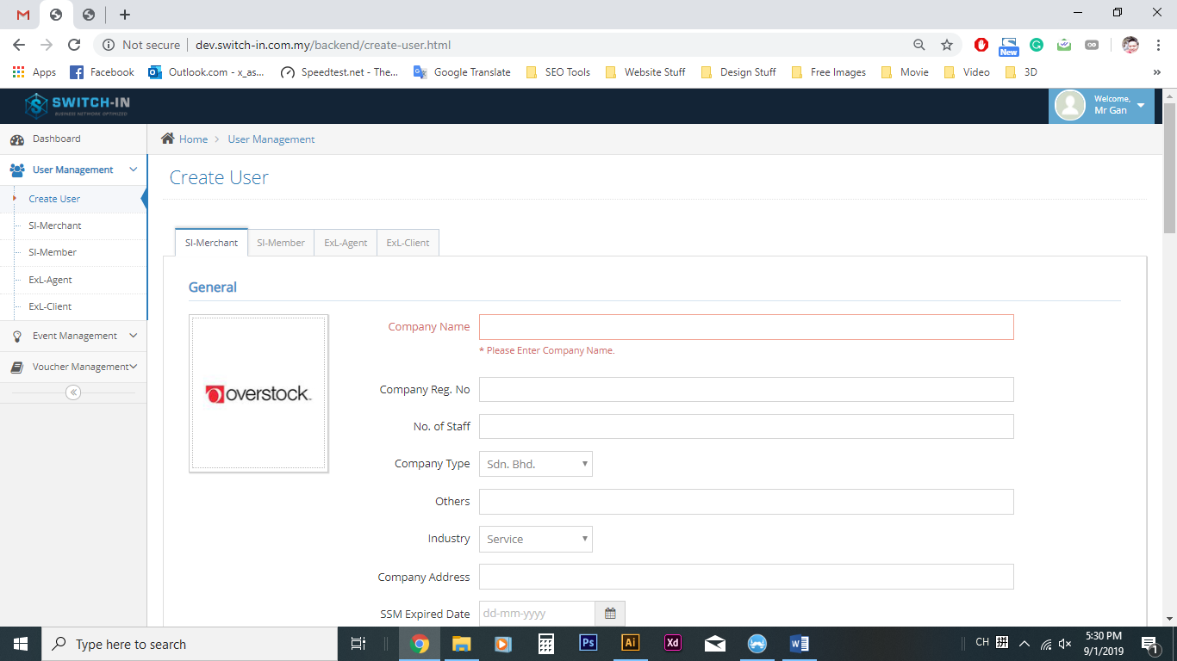

**Create User**

SI-Merchant

1. Company name (Please enter company name)
2. Username (Please enter username)
3. Password (Password between 6 and 20 characters; must contain at least one lowercase letter, one uppercase letter, one numeric digit)
4. Email (Please enter an valid email)
5. Phone(Please enter an valid phone number)

SI-Member

1. Username (Please enter username)
2. Password (Password between 6 and 20 characters; must contain at least one lowercase letter, one uppercase letter, one numeric digit)
3. Name(Please enter your name)
4. Email(Please enter an valid email)
5. Phone(Please enter an valid phone number)

Exl-Agent

1. Username (Please enter username)
2. Password (Password between 6 and 20 characters; must contain at least one lowercase letter, one uppercase letter, one numeric digit)
3. Name(Please enter your name)
4. Email(Please enter an valid email)
5. Phone(Please enter an valid phone number)

Exl-Member

1. Username (Please enter username)
2. Password (Password between 6 and 20 characters; must contain at least one lowercase letter, one uppercase letter, one numeric digit)
3. Name(Please enter your name)
4. Email(Please enter an valid email)
5. Phone(Please enter an valid phone number)

**Event Management**

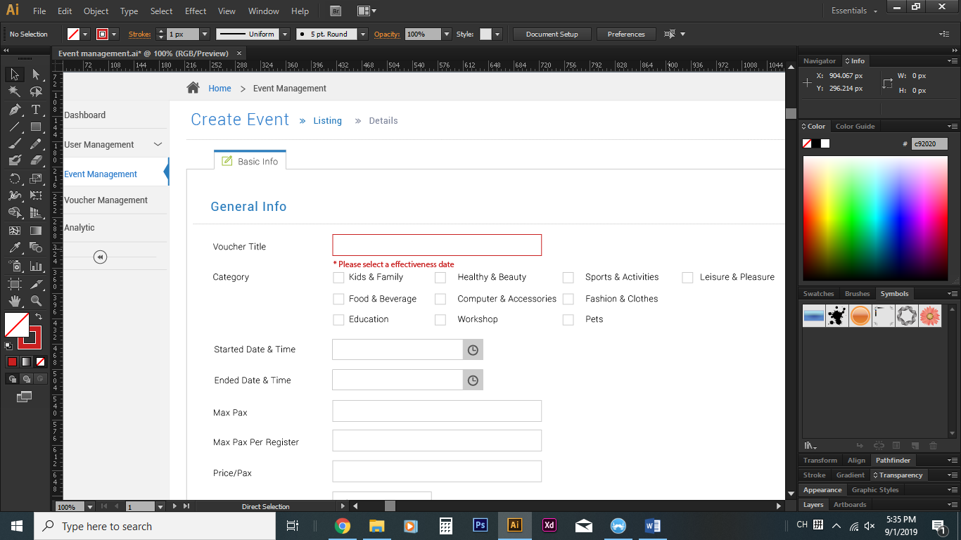

1. Voucher title (Please enter a voucher title)
2. Category (Please choose at least one category)
3. Started date & time (Please select a effectiveness date)
4. Ended date & time (Please select a effectiveness date)
5. Max Pax(Please enter number of maximum pax)
6. Max Pax Per Register(Please enter number of max pax per register)
7. Price per pax (Please enter a price per pax)
8. Location (Please choose location)
9. Address (Please enter your event address)
10. Merchant ID (Please choose a merchant) *only for super admin create event

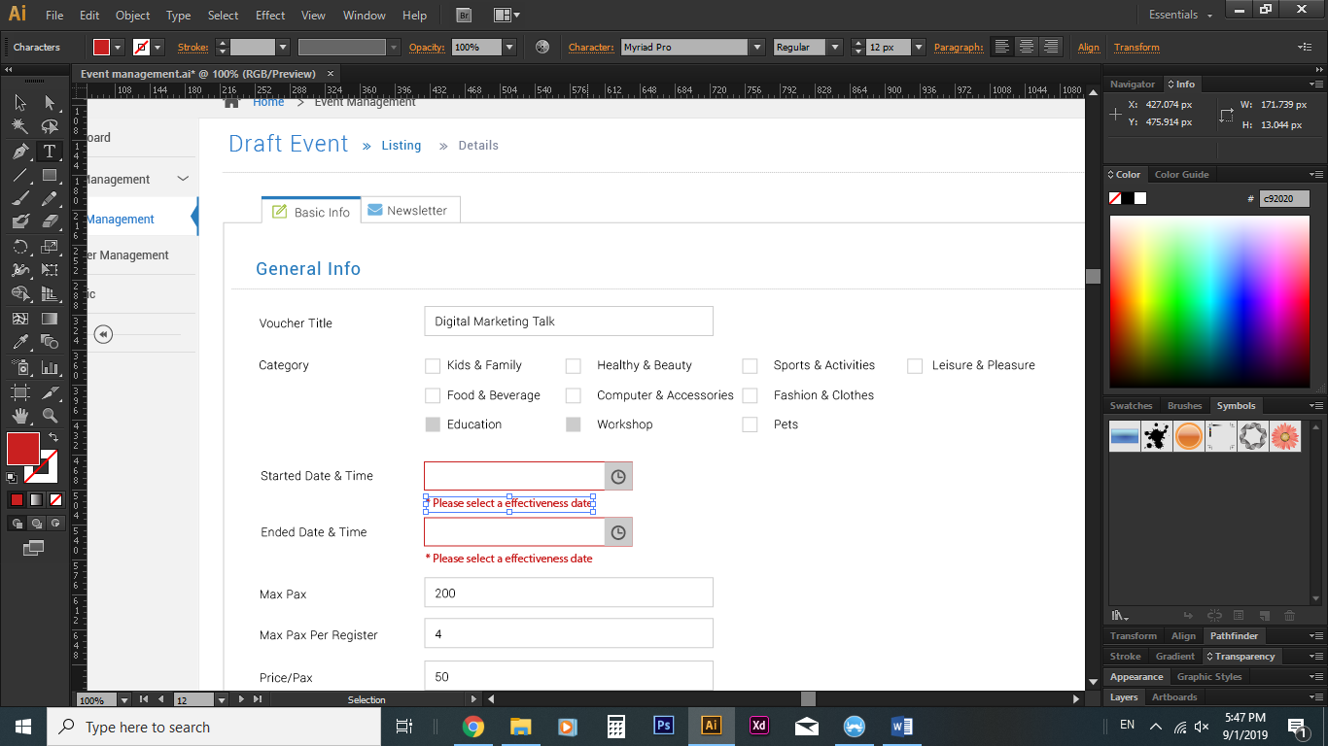

Reactive event will show this error message in draft event

**Voucher Management**

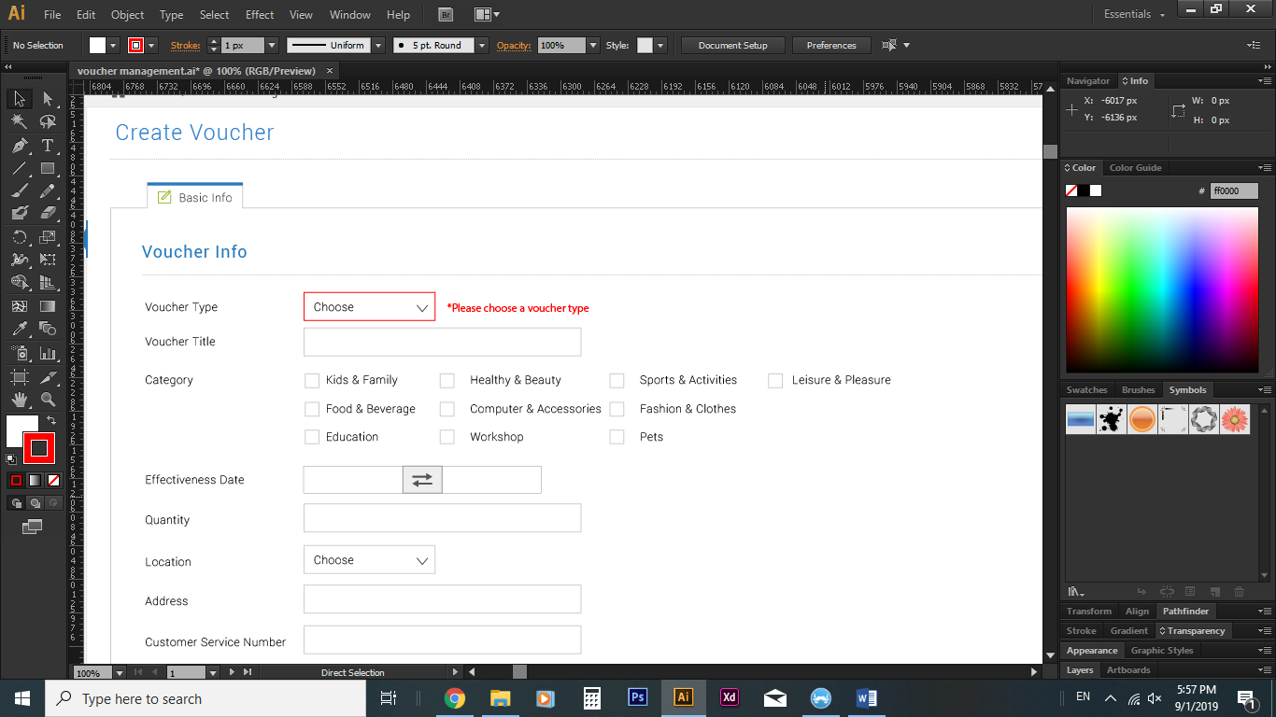

1. Voucher type(Please choose a voucher type)
2. Voucher title (Please enter a voucher title)
3. Category (Please choose at least one category)
4. Effectiveness Date (Please select an effectiveness date)
5. Quantity (Please enter a number of voucher)
6. Location(Please choose a location)
7. Address (Please enter your address)
8. Merchant ID (Please choose a merchant) *only for super admin create voucher